# **Citizen AI – Intelligent Citizen Engagement Platform**

## Introduction

## ****Project Title:**** Citizen AI – Intelligent Citizen Engagement Platform

**Team Leader:** Madhumitha A

**Team Members: Rabiyath Mushitha Y**

**Fathima A**

## 2. Project Overview

**Purpose:**  
Citizen AI is an AI-powered platform designed to improve interactions between citizens and government or civic organizations. It focuses on making public services more accessible, transparent, and personalized.

**Core Functionalities:**

1. **Citizen Query Resolution** – AI-powered chat bot to handle citizen queries on government services, schemes, and policies.
2. **Service Request Management** – Allows users to raise service requests (e.g., waste management, complaints) and track their status
3. **Feedback & Sentiment Analysis** – Collects and analyzes citizen feedback to improve governance quality.
4. **Community Engagement** – Provides announcements, polls, and updates from local authorities.

**Key Features:**

Multi-channel Support (Web, Mobile, WhatsApp, Voice Assistants)

Multilingual Conversations

AI-driven Insights & Prioritization of Issues

Personalized Notifications

Transparent Tracking of Requests

## 3. Architecture

**Frontend:**

Built with Gradio or React-based UI.

Provides chat interface, dashboards, and request tracking view.

**Backend (Python):**

Handles natural language understanding (NLU), classification, and response generation.

Uses rules + AI model for accurate information retrieval.

**LLM Integration:**

Uses ibm-granite/granite-3.2-2b-instruct for conversational AI.

Integrates with government service APIs for real-time data.

**Deployment Layer:**

Can be deployed on local servers, cloud platforms, or public domain with secure access.

## 4. Setup Instructions

**Prerequisites:**

Python 3.9+

pip & virtual environment tools

Hugging Face Transformers & Torch

REST API access to government datasets (optional)

**Installation:**

1. Clone repository
2. Install dependencies from requirements.txt
3. Run: python app.py
4. Access the platform via browser

## 5. Folder Structure

app/ – Main application folder

├── citizen_query.py – AI-driven query handling

├── service_request.py – Service request management

├── feedback_analysis.py – Sentiment & feedback module

├── model_loader.py – Loads IBM Granite LLM

├── interface.py – Defines UI (Gradio/React)main.py – Entry script

requirements.txt – Dependencies

README.md – Documentation

## 6. Running the Application

Run:

python main.py

Platform launches at: http://127.0.0.1:7860  
Public link available with share=True

1. **Screenshots**

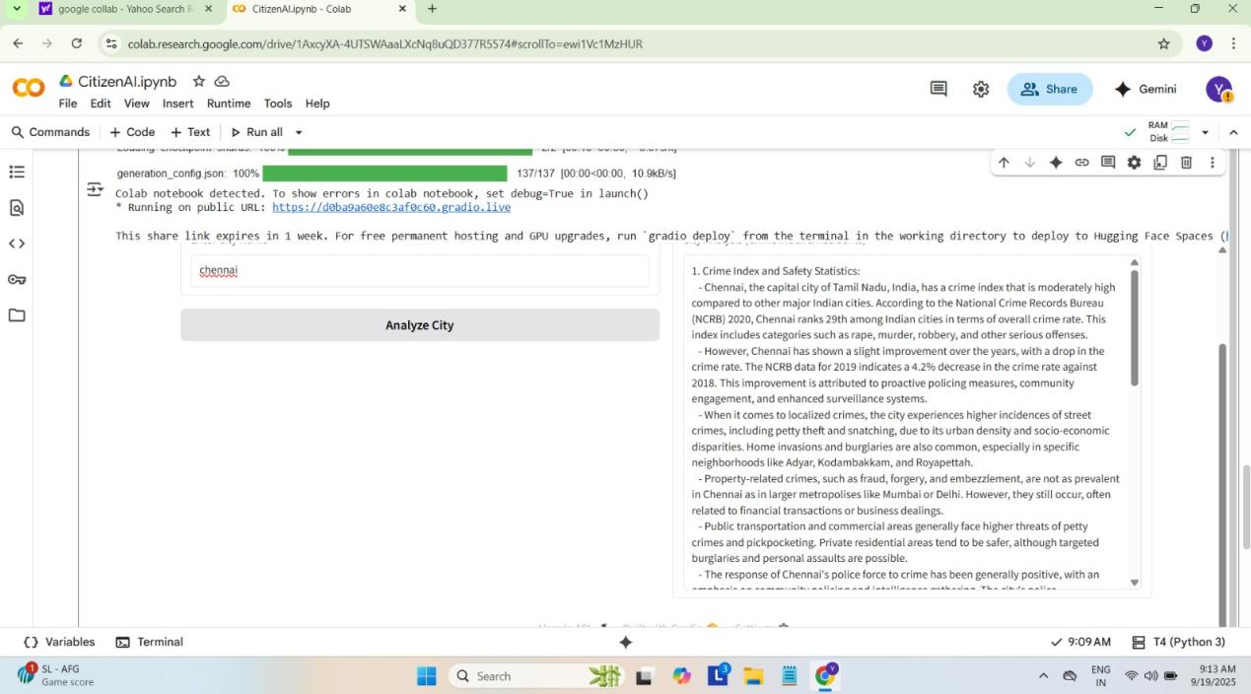

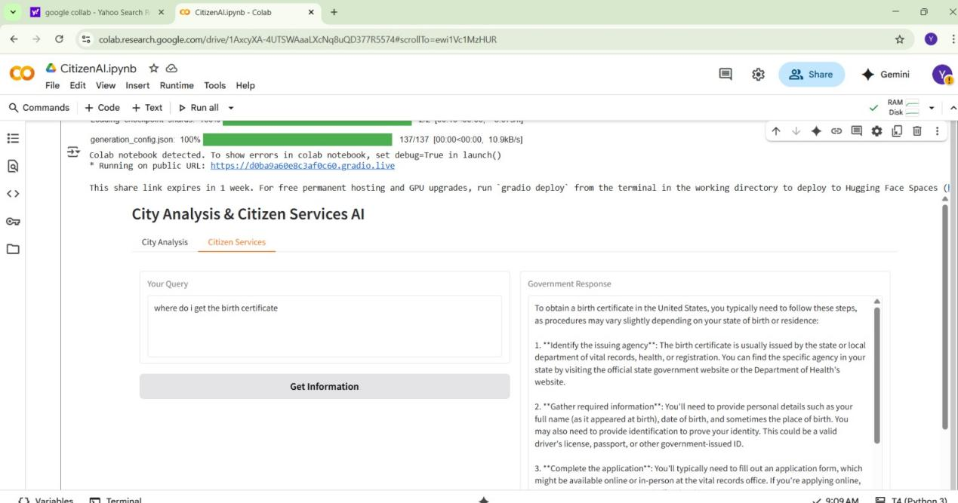

## 8.API Documentation (Future Integration)

POST /citizen-query → Returns response to user query

POST /service-request → Creates and tracks service requests

GET /feedback → Retrieves citizen feedback & analysis results

## Authentication

Role-based access (Citizen, Admin, Officer)

Secure authentication with JWT or OAuth2

## 9. User Interface

**Modules:**

**1.Chatbot Interface** – Ask queries about services

**2.Service Request Panel** – Submit, view, and track issues

**3.Feedback Dashboard** – Provide feedback, see community ratings

**4.Announcements Board** – Get latest civic updates

## 10.Testing

Unit tests for query classification & response accuracy

Manual testing with multiple citizen scenarios

Load testing for concurrent users

## 11. Known Issues

AI may sometimes return generic responses

Latency in fetching real-time government data

Requires multilingual fine-tuning for some dialects

## Future Enhancements

Integration with voice assistants (Alexa, Google Assistant)

Predictive analytics for issue prioritization

Mobile app deployment

Automated grievance redressal system

Community participation gamification (badges, points)

## 12.Conclusion

Citizen AI is designed to bridge the gap between citizens and civic authorities by providing a seamless, AI-powered communication channel. Through intelligent query resolution, transparent service request tracking, and actionable feedback insights, the platform empowers citizens and promotes better governance.